Lawn Care Company Name
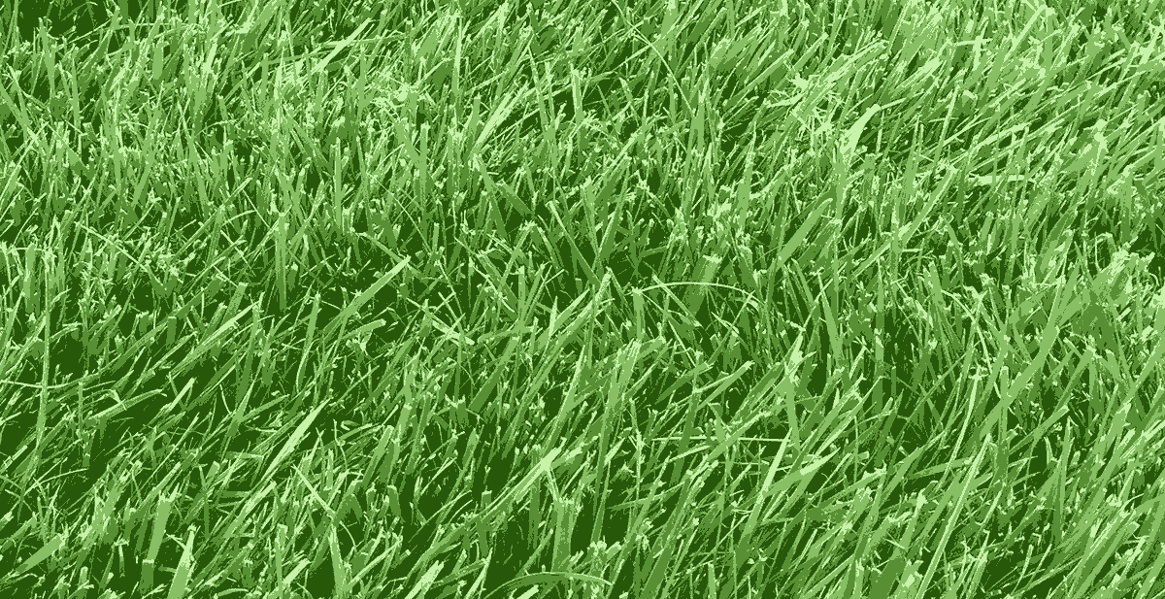 | You have better things to do,  so let us do the yard work!
 |  | Services |  | Prices
 |  | Lawn Mowing  Hedge Trimming  Fertilizing  Aerating  Weed Control  Bug Control |  | Mowing  $79  Whole Yard Care  (up to 1200 sq ft.)  $199
 | City Name | Suburb Name | City Name
Contact Larry Smith | (123) 456-7890 | lsmith@email.com | www.my-website.com
Lawn Care Company Name
You have better things to do,
so let us do the yard work!
 |  | Services |  | Prices
 |  | Lawn Mowing  Hedge Trimming  Fertilizing  Aerating  Weed Control  Bug Control |  | Mowing  $79  Whole Yard Care  (up to 1200 sq ft.)  $199
 | City Name | Suburb Name | City Name
Contact Larry Smith | (123) 456-7890 | lsmith@email.com | www.my-website.com

