Company / Project Title
  - EXECUTIVE SUMMARY

Overview - The Quick Pitch
This is a brief section that describes what your business or project is all about.

TIP: The ability to describe what your business does in just one compelling sentence
will be a huge asset to you as you talk about it with others.

The Problem
Here is where you describe the problem that you are solving.

- What is the problem and how big is it?
- Who is the target audience? Who is this problem affecting?
- Are there currently any solutions to this problem? Who is the competition?

The Solution
Here you describe how your business solves the problem for your target audience.

- How does your business solve the problem?
- Is it a simple or complex solution?
- If it is complex, how can you make it simple, or describe it more simply?

Highlights
Here you can show the most important market analysis and data that captures the potential your solution can have in the marketplace. We recommend pulling the most compelling highlights from your plan or proposal. You can also talk about the strengths and advantages of your staff and any partnerships you may have.

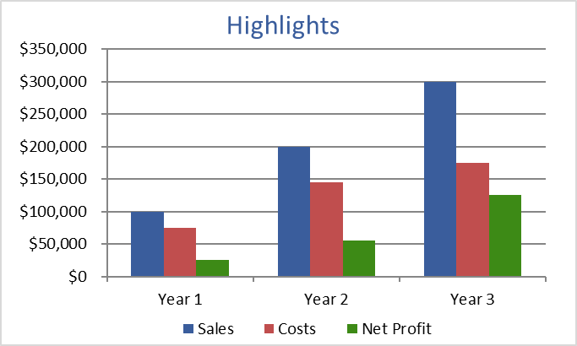
[Optional caption for graph]

Keys to Success
Discuss the main steps necessary for your business to be successful.

- What is your marketing strategy?
- What resources will you need? (partnerships, funding, materials)
- What does your timeline look like?

Financial Highlights
If part of the purpose of your proposal is to seek funding, you may want to dedicate a full section to talk about the funding you currently have and what funding you'll need.

- What is your 3-year earnings projection?
- When will you break even?
- How will investors be repaid?

How to use this Executive Summary Template
Replace Sample Text
The section titles, descriptions, questions and tips are all meant to help make it easier for you to write your executive summary. Feel free to change anything to best fit your needs and replace the text as you go.

Theme & Font Style Customization
This template is using font styles for headings, subtitles, paragraph text, etc. You can easily explore different fonts and colors by changing the theme under Design > Themes.

Remove this Page
After reviewing the terms of use, you may remove this page. The terms of use still apply, but we don’t expect you to keep this page attached to your executive summary.

Other related templates
Business Plan Template
https://www.vertex42.com/WordTemplates/business-plan-template.html

Business Startup Costs Template
https://www.vertex42.com/ExcelTemplates/business-startup-costs.html

Business Budget Template
https://www.vertex42.com/ExcelTemplates/business-budget.html

Break Even Analysis Template
https://www.vertex42.com/ExcelTemplates/breakeven-analysis.html

Terms of Use
By Vertex42.com
https://www.vertex42.com/WordTemplates/executive-summary.html

Executive Summary Template © 2019 Vertex42 LLC

This template, including all associated content is a copyrighted work under the United States and other copyright laws. Do not submit copies or modifications of this template to any website or online template gallery.

Please review the following license agreement to learn how you may or may not use this template. Thank you.
License Agreement: https://www.vertex42.com/licensing/EULA_privateuse.html

