Cleaning Service Name
Let us do the cleaning so you can do the living!
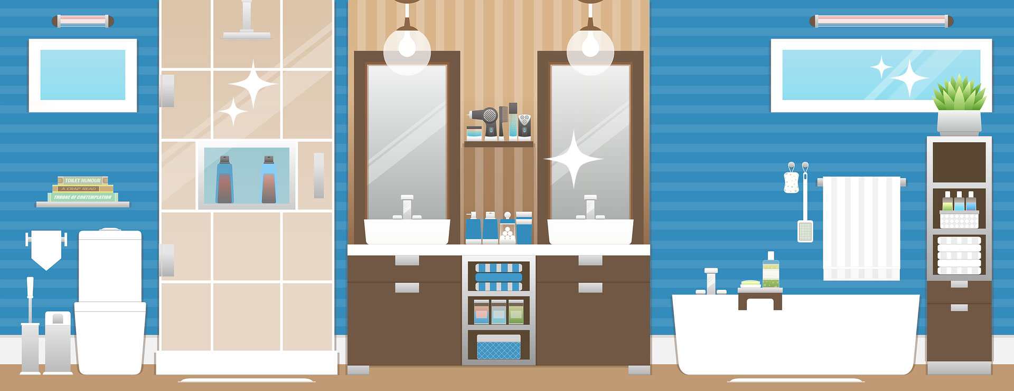
 | Services |  | Areas |  | Prices
 | Kitchens  Bedrooms  Bathrooms  Living Areas  After Parties  Move in/out  Offices |  | City Name  Suburb Name  Suburb Name  City Name |  | 3 Rooms  $79  Whole House  (up to 1200 sq ft.)  $199
The best cleaning service in City Name
for over 10 years.
Contact Mary Smith | (123)456-7890 | mary.smith@company.com | www.company-site.com

