Lawn Care Company Name
You’ve got better things to do, so let us do the yard work!
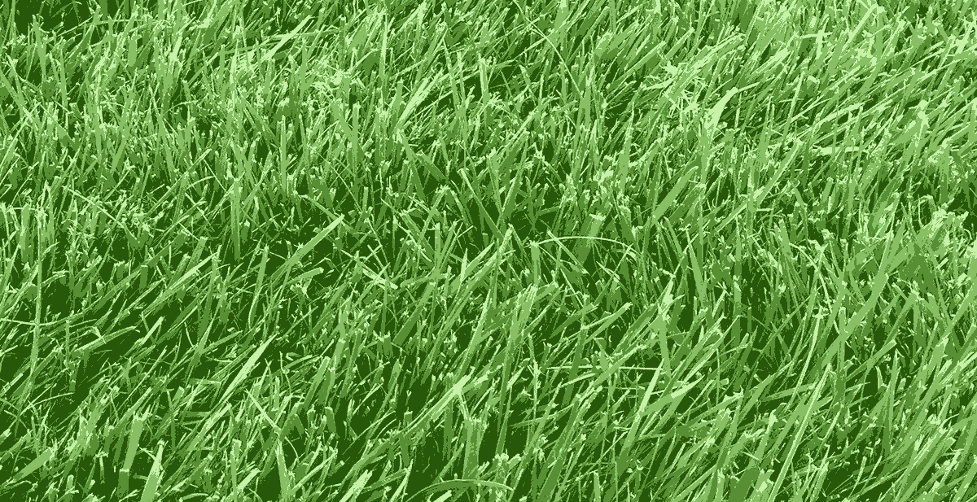
 | Services |  | Areas |  | Prices
 | Lawn mowing  Hedge Trimming  Fertilizing  Aerating  Weed Control  Bug Control |  | City Name  Suburb Name  Suburb Name  City Name |  | Mowing  $79  Whole Yard Care  (up to 1200 sq ft.)  $199
The best lawn care company in City Name
for over 10 years.
Contact Larry Smith | (123)456-7890 | larry.smith@company.com | www.company-site.com

