FOR SALE  BY OWNER |  |  |  |  | $343,210  1234 Any Street, City Name, ST 12345
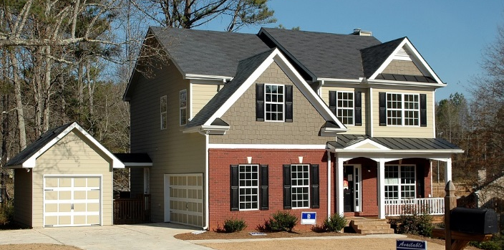
 | 3,200 sq. ft.  4 Bedrooms  3.5 Bathrooms  3 Car Garage |  |  | 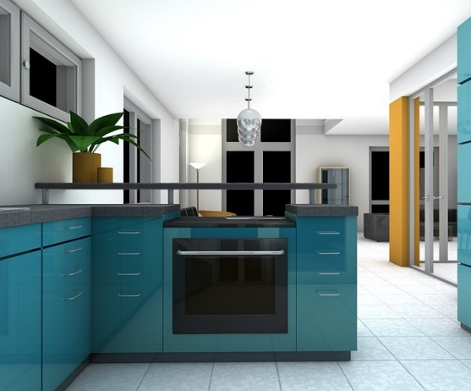 |  |  | 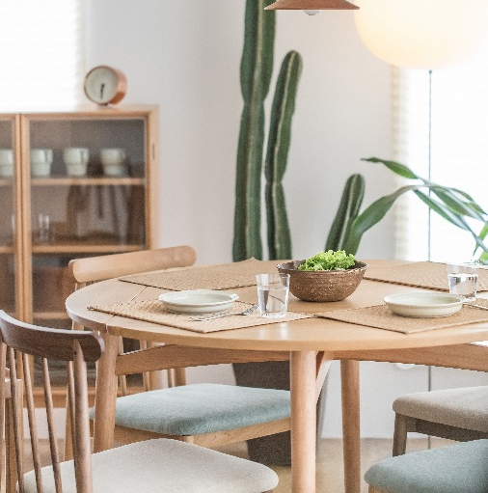
Property Highlights
Walk-in closet in master bedroom
Laundry room
Energy-Star rated windows
Programmable thermostat
Granite countertop in the kitchen
Contact Owner: Roger Smith | (123) 456-7890 | rsmith@email.com

