FOR SALE  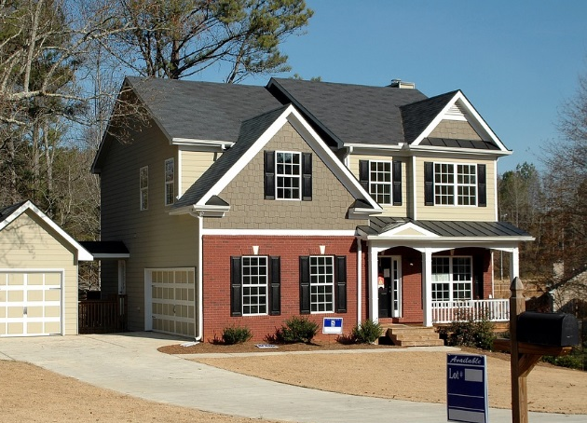  BY OWNER | $343,210  1234 Any Street, City Name, ST 12345
3,200 sq. ft.
4 Bedrooms
3.5 Bathrooms
3 Car Garage
Walk-in closet in master bedroom
Laundry room
Energy-Star rated windows
Programmable thermostat
Granite countertop in the kitchen
Contact Owner: Roger Smith | (123) 456-7890 | rsmith@email.com
FOR SALE  BY OWNER | $343,210  1234 Any Street, City Name, ST 12345
3,200 sq. ft.
4 Bedrooms
3.5 Bathrooms
3 Car Garage
Walk-in closet in master bedroom
Laundry room
Energy-Star rated windows
Programmable thermostat
Granite countertop in the kitchen
Contact Owner: Roger Smith | (123) 456-7890 | rsmith@email.com

